Sustainable Supply Chain Management using

Power BI Dashboard

**Introducution :**

Sustainable supply chain management focuses on creating long-term value for businesses, society, and the environment. It involves managing the flow of goods and services in a way that reduces environmental impact, supports social responsibility, and ensures economic viability. This approach includes sourcing materials responsibly, reducing waste, and promoting fair labor practices, all while striving for profitability.

Steps done so far :

1. Created a file named : Sustainable supply chain management using power BI dashboard.

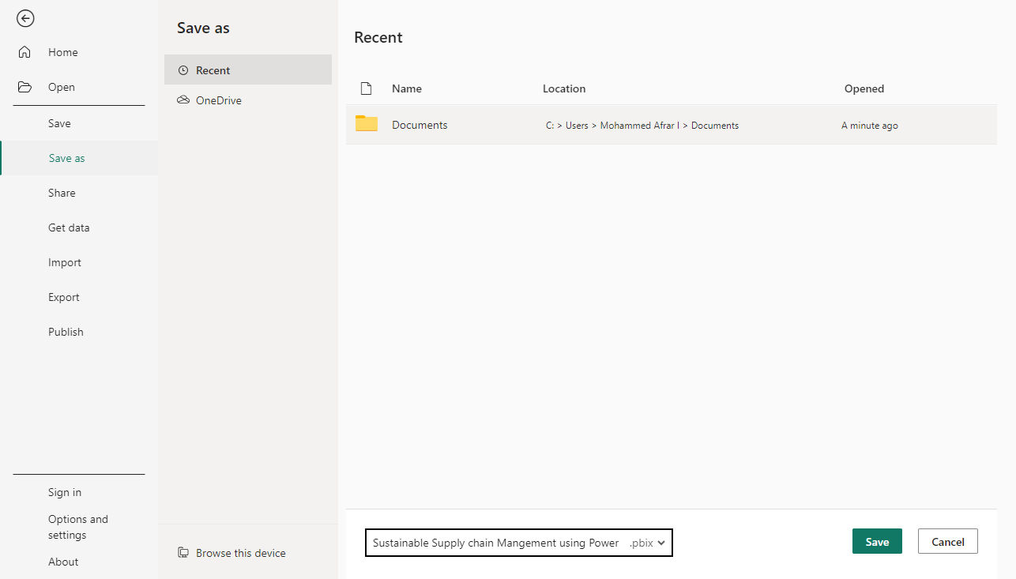

1. After creating file we need to import the data for further analysis which can be done by importing from more no of sources in Power BI

Here, from CsvFile named : Sustainable Supply Chain Performance , the data’s are imported in Power BI

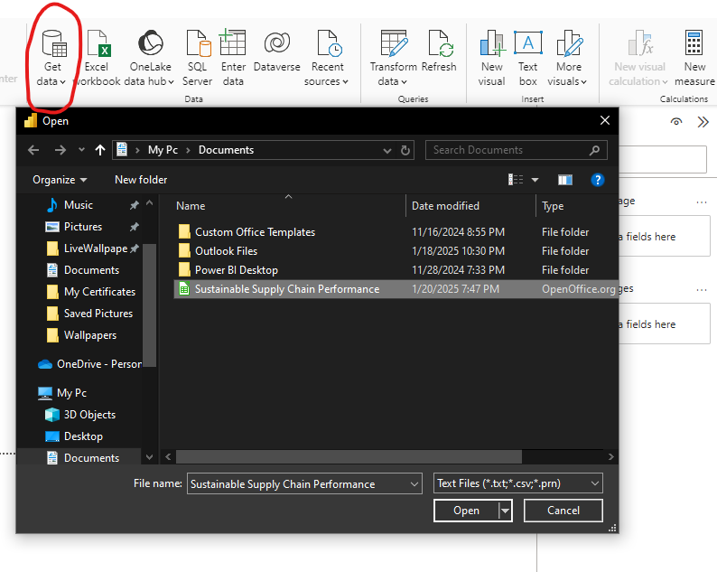

1. Then after importing the data, we need to categorize the data by transform data option in power BI

For this topic we need:

1. Inventory Table
2. Manufacturing Table
3. Supplier Table
4. Supply Chain Table

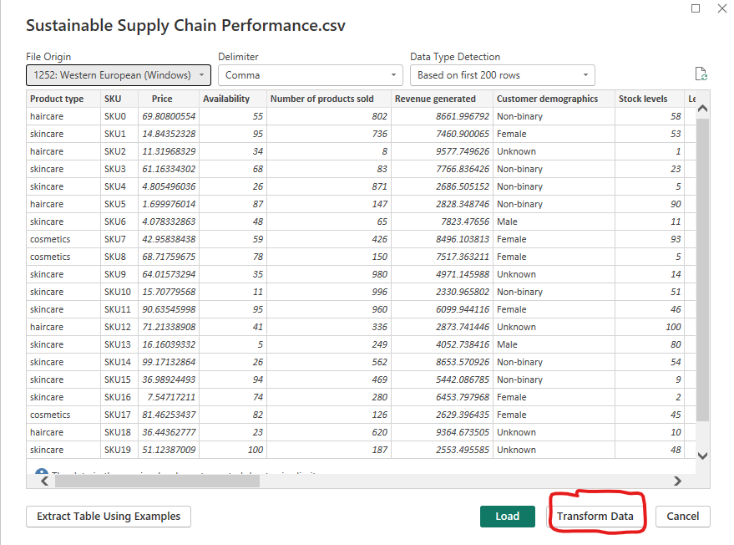

* From the data file .csv imported we need to make a duplicate of the data set and rename it accordingly by names given above.
* Also select the columns required for the particular table and

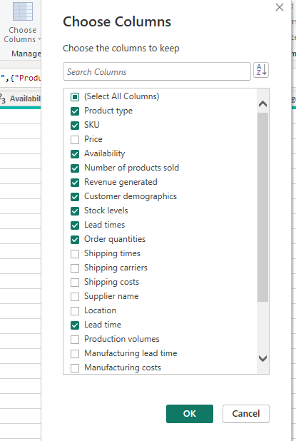

1. Now, the dataset from the csv file has been categorized accordingly for analysis

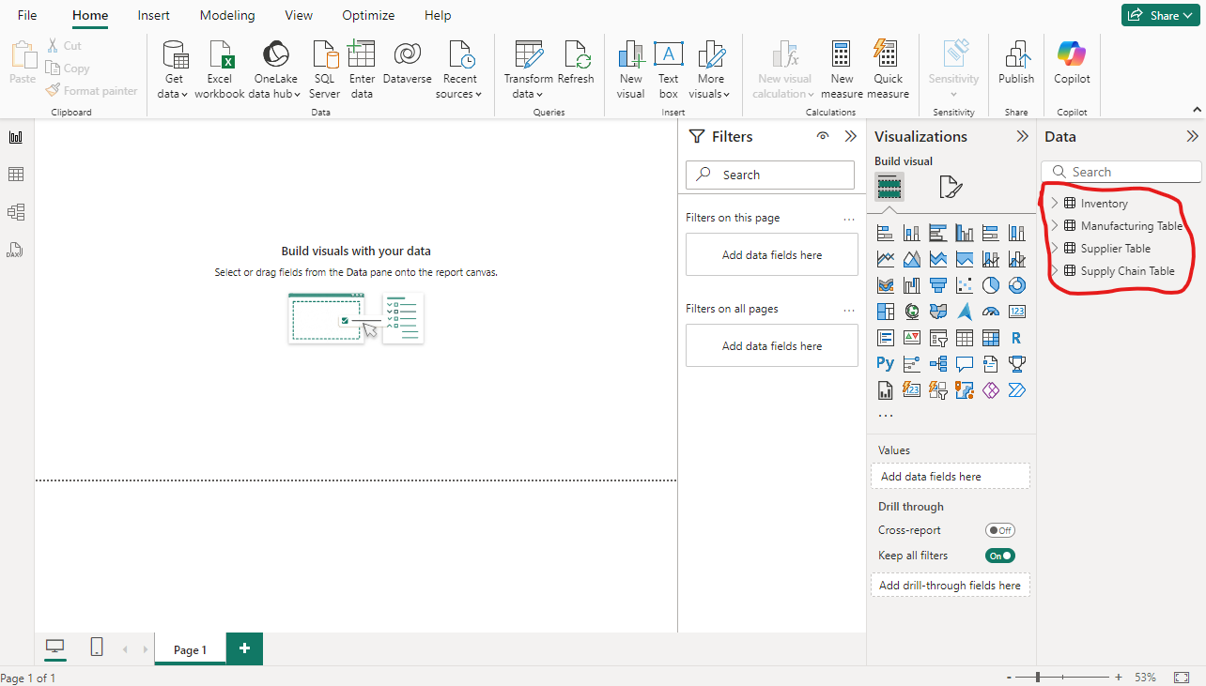

**Note:** As the dataset in the csv file is already cleaned we need not to clean the data’s present in the file.

**End Goal :**

Our final goal of the project is focused on Sustainable Supply Chain Management using Power BI Dashboard is to create an interactive and insightful dashboard that helps businesses monitor and improve the sustainability of their supply chains.

By,

Mohammed Afrar I